
QUALITY ALERT

Customer: Soft-Lite Date: November 16, 2018
Die: 15238 / 15191 / 15192 Colour: ALL
Type of Complaint: HPAC REJECTED

Q.A # Q.I.R # CUSTOMER NCR #

Description: HPAC Rejected due to gap too wide / moving when panel is snapped together due to missing corners

GOOD
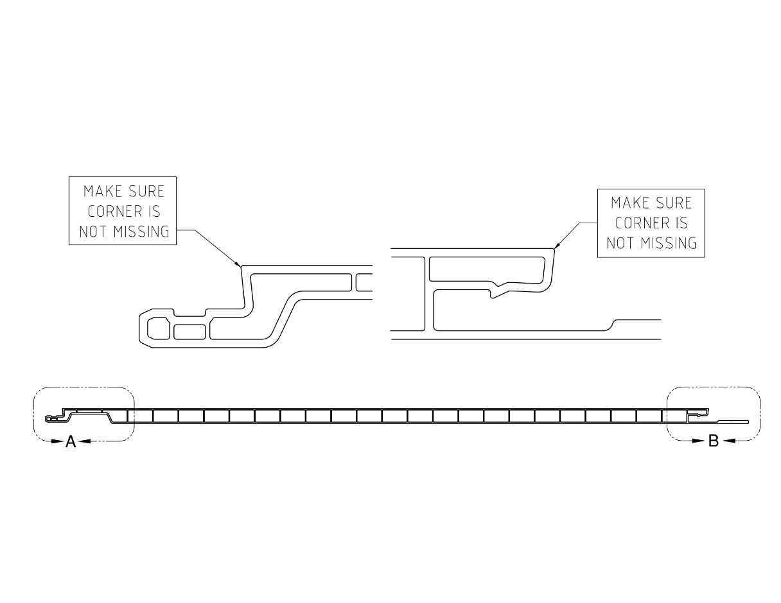
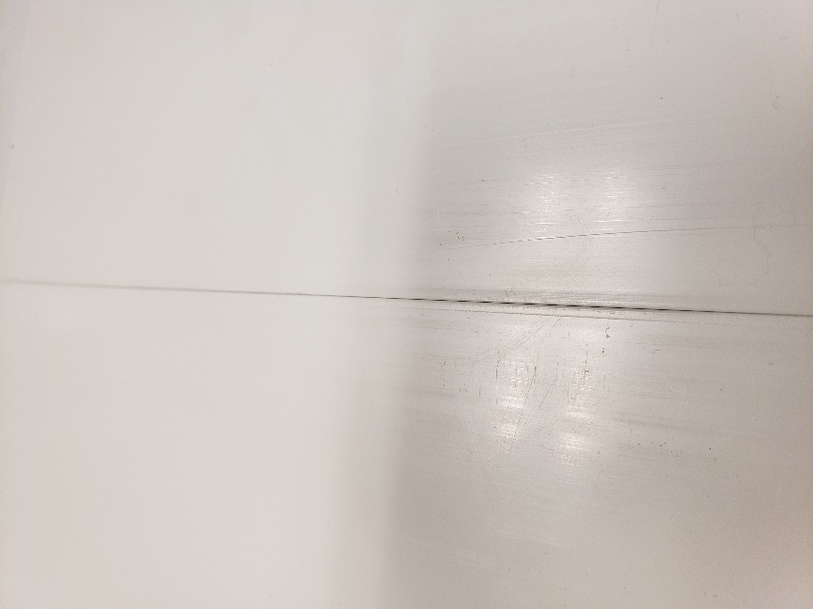

BAD

BY SIGNING BELOW, YOU ACKNOWLEDGE THE PROBLEM ABOVE AND AGREE TO MONITOR THIS ISSUE IN FUTURE PRODUCTION RUNS.
DAY SHIFT |  | AFTERNOON SHIFT |  | NIGHT SHIFT
NAME | SIGNATURE | NAME | SIGNATURE | NAME | SIGNATURE

